ISCG7424 Mobile Software Development

Semester 2, 2022

**Assignment 2: Trivia Quiz**

**User Guide**

Submitted by

Anna McColl

Prepared for Tariq Khan

Date Submitted: 14th November 2022

1.0 Table of Contents

2.0 Table of Figures 2

3.0 Introduction 3

4.0 Login 3

5.0 Administrator Functions 4

5.1 Administrator Menu. 4

5.2 Register Admin User 5

5.3 Create Quiz 6

5.4 All Quizzes 9

5.4.1 Update Quiz 12

5.4.2 Delete Quiz 14

5.5 Logout 15

6.0 Player Functions 15

6.1 Register Player User 15

6.2 Player Menu 16

6.3 Ongoing Quizzes 16

6.3.1 Take Quiz 17

6.4 Upcoming Quizzes 21

6.5 Past Quizzes 22

6.6 Participated Quizzes 23

6.7 Logout 24

# 2.0 Table of Figures

Figure 1: Login Form. 3

Figure 2: Administration Menu. 5

Figure 3: Registration Form. 6

Figure 4: Create Quiz. 7

Figure 5: Calendar Widget. 8

Figure 6: Preview Quiz. 9

Figure 7: All Quizzes. 10

Figure 8: All Quizzes (displaying a Take Quiz button). 11

Figure 9: All Quizzes Options Menu. 12

Figure 10: Update Quiz Form. 13

Figure 11: Calendar Widget. 14

Figure 12: Delete Quiz Dialog. 15

Figure 13: Player Menu. 16

Figure 14: Ongoing Quizzes. 17

Figure 15: Question Form. 18

Figure 16: Answer Form. 19

Figure 17: Final Answer Form. 20

Figure 18: Quiz Result Form. 21

Figure 19: Upcoming Quizzes. 22

Figure 20: Past Quizzes. 23

Figure 21: Participated Quizzes. 24

# 3.0 Introduction

This Trivia Quiz application allows users to take trivia quizzes containing 10 questions each. There are two user types, an Administrator and a Player.

An Administrator can create quizzes, view quiz summaries, update, and delete them. A Player can view summaries of past, upcoming and participated quizzes. Both Administrators and Players can undertake quizzes if they are current. Quizzes that have been participated in will show the user’s score.

# 4.0 Login

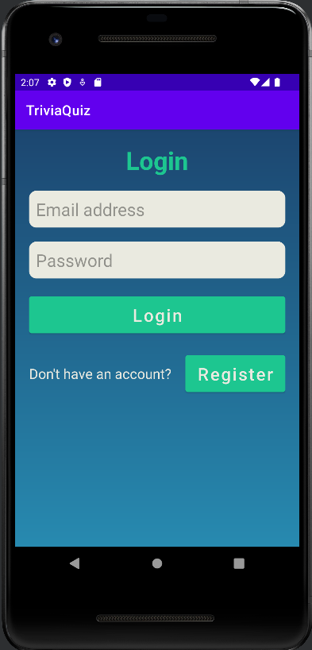

Figure : Login Form.

The Login form (see figure 1) allows both a Player and Administrator to log in to the application by entering their email address and password ,and clicking the *Login* button. If a new Player wishes to begin using the application, they must click the *Register* button, which will take them through to the Registration activity.

# 5.0 Administrator Functions

## 5.1 Administration Menu

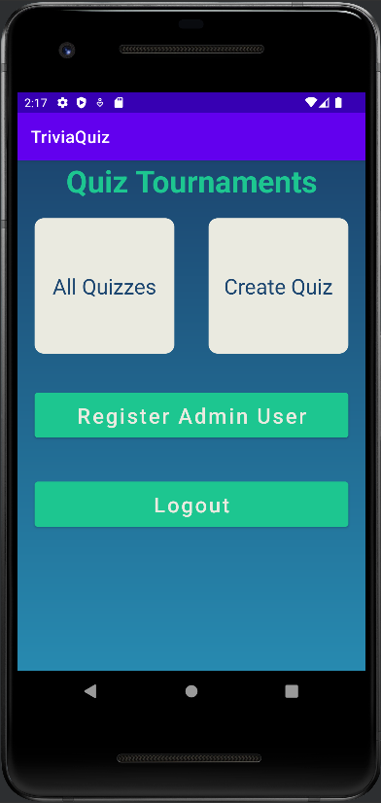

Figure : Administration Menu.

Once an Administrator has logged in, they are taken to the Administration Menu (see figure 2). The Administration Menu contains the buttons *All Quizzes*, *Create Quiz*, *Register Admin User*, and *Logout*.

## 5.2 Register Admin User

Clicking on the *Register Admin User* button in the Administration Menu takes the user to the Registration form (see figure 3). Only an Administrator can create another Administrator. The Registration form asks for the username, email address and password. The email address and password are required fields. When the *Register* button is clicked, the Administrator is returned to the Administration Menu.

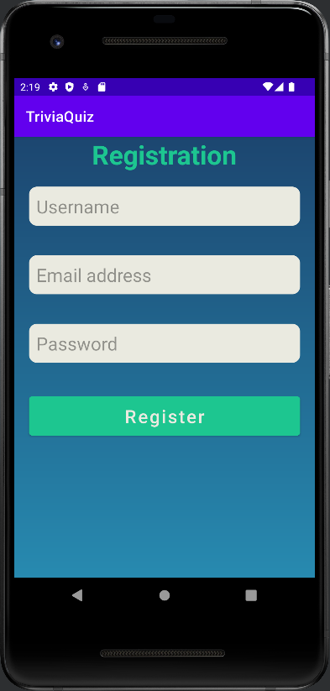

Figure : Registration Form.

## 5.3 Create Quiz

When an Administrator clicks on the *Create Quiz* button in the Administration Menu, they are taken to the Create Quiz form (see figure 4). The Administrator can enter a name for the quiz, and they can select a category and difficulty level from drop down options. Clicking on the *Start Date* and *End Date* buttons will open a calendar widget (see figure 5) to allow the Administrator to select the start and end dates of the quiz.

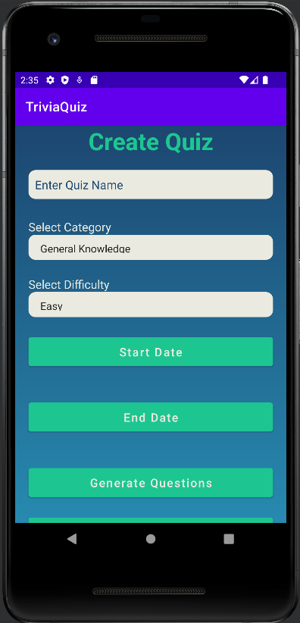 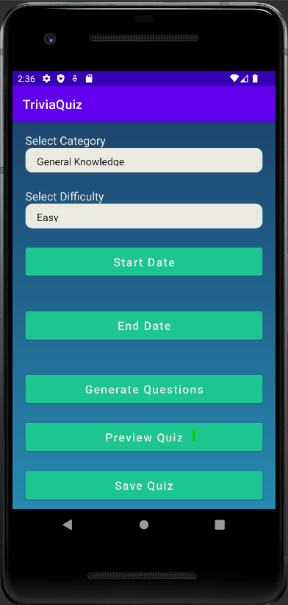

Figure : Create Quiz.

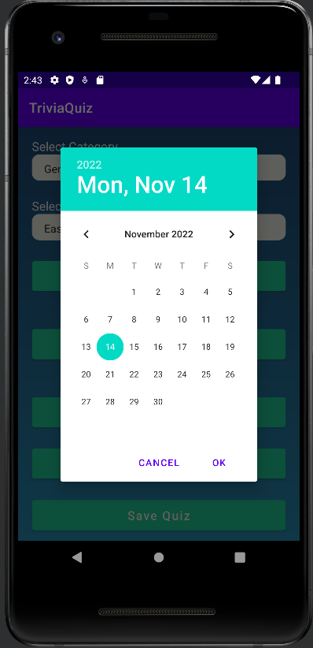

Figure : Calendar Widget.

By clicking the *Generate Questions* button, the application sends out an API request specifying the category and difficulty selected.

Clicking the *Preview Quiz* button displays the questions and answers generated previously (see figure 6).

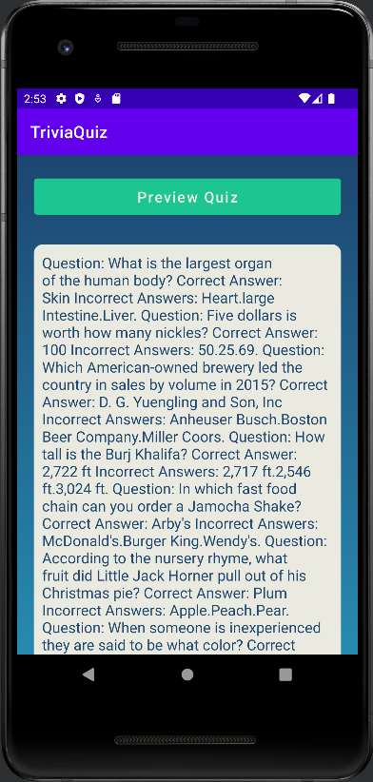

Figure : Preview Quiz.

Clicking the *Save Quiz* button saves the quiz to the application database and returns the Administrator to the Administration Menu.

## 5.4 All Quizzes

Clicking on the *All Quizzes* button in the Administration Menu takes the Administrator to the list of all quiz summaries (see figure 7). Each quiz’s name, start date, end date, category and difficulty are listed. If the Administrator has taken the quiz, their score is displayed at the end of the quiz summary.

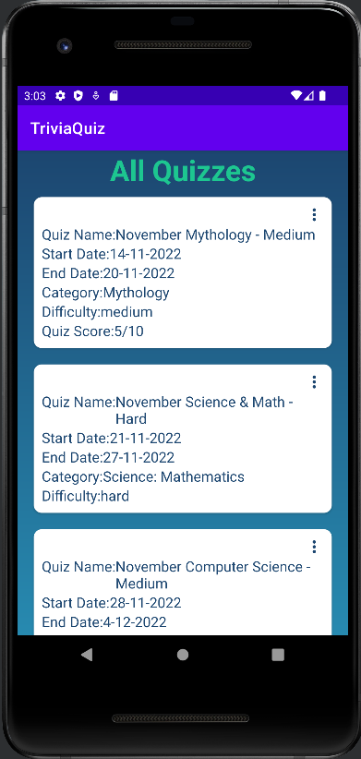

Figure : All Quizzes.

Figure : All Quizzes (displaying a Take Quiz button).

If the Administrator has not yet taken the quiz, a *Take Quiz* button will be displayed (see figure 8).

By clicking on the three dots to the upper right hand of each quiz summary, a dropdown menu will appear with options to *Update Quiz* or *Delete Quiz* (see figure 9).

Figure : All Quizzes Options Menu.

### 5.4.1 Update Quiz

Selecting the *Update Quiz* option in the dropdown menu will take the Administrator to the Update Quiz form (see figure 10). The quiz name is prepopulated in an editable field. The category and difficulty are not able to be updated. The current start and end date are displayed beneath the *Change Start Date* and *Change End Date* buttons. Clicking on either of these buttons will open a calendar widget allowing the Administrator to select a new date (see figure 11).

Clicking the *Update Quiz* button will update the application’s database and return the user to the All Quizzes list.

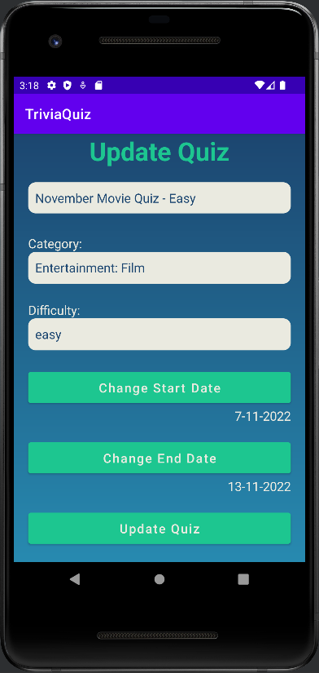

Figure : Update Quiz Form.

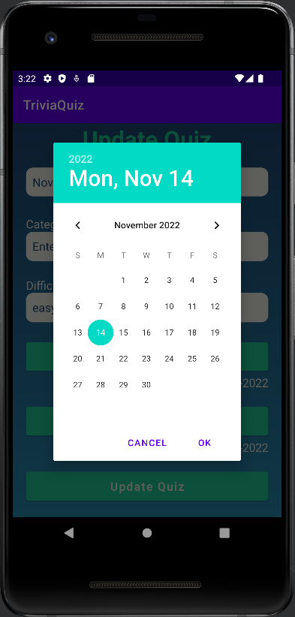

Figure : Calendar Widget.

### 5.4.2 Delete Quiz

Selecting the *Delete Quiz* option in the dropdown menu will open the Delete Quiz dialog (see figure 12). By clicking on the *Cancel* option, the dialog is closed and no changes are made to the application database.

If the Administrator selects *OK*, the quiz is deleted from the application database and removed from the list of All Quizzes.

Figure : Delete Quiz Dialog.

## 5.5 Logout

By clicking the *Logout* button on the Administration Menu (see figure 2), the Administrator is logged out and returned to the Login activity (see figure 1).

# 6.0 Player Functions

## 6.1 Register Player User

If a Player wishes to register an account they need to click the *Register* button on the Login Form (see figure 1). They are then taken to the same registration form as in figure 3. The process to register a Player is the same as for an Administrator (see section 5.1 Register Admin User), however after clicking the *Register* button, the Player is taken back to the Login Form.

## 6.2 Player Menu

After completing Login, the Player is taken to the Player Menu (see figure 13). The Player can select between the *Ongoing*, *Upcoming*, *Past* and Participated or *Logout* buttons.

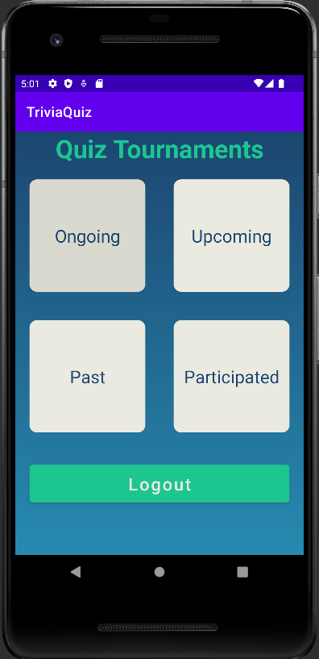

Figure : Player Menu.

## 6.3 Ongoing Quizzes

By clicking the *Ongoing* button, the Player is taken to a list of quizzes that are presently open (see figure 14). If the Player has not taken the quiz, the *Take Quiz* button is available to click.

As with All Quizzes (see section 5.4 All Quizzes), if the quiz has already been taken, the *Take Quiz* button will not be displayed, but the quiz score will be.

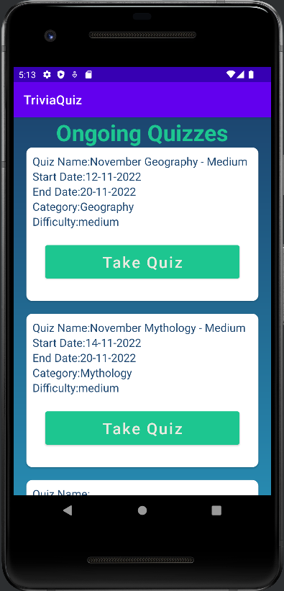

Figure : Ongoing Quizzes.

### 6.3.1 Take Quiz

After clicking the *Take Quiz* button, the first question of the quiz appears (see figure 15). The user can select the answer to the question from four buttons.

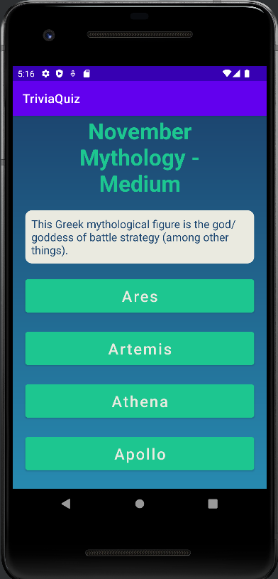

Figure : Question Form.

After clicking on the answer to the question, the user is taken to the answer form. The user receives feedback on whether their answer was correct or not (see figure 16). If the answer was incorrect, the user is given the correct answer.

The user clicks on the *Next Question* button to start the next question of the quiz.

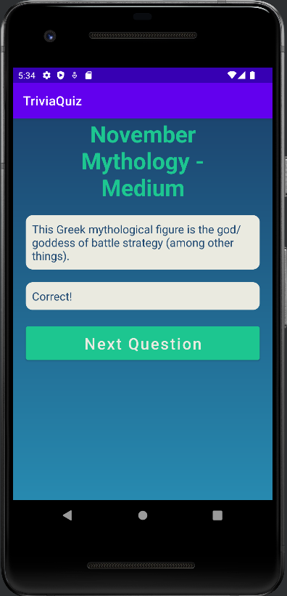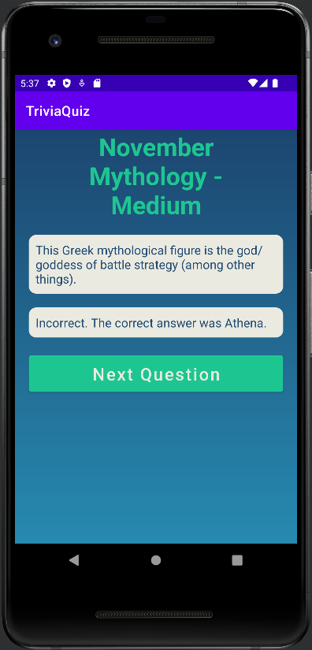

Figure : Answer Form.

The results form for the final question has a button that invites the user to *Get Results*, rather than continue to the *Next Question* (see figure 17).

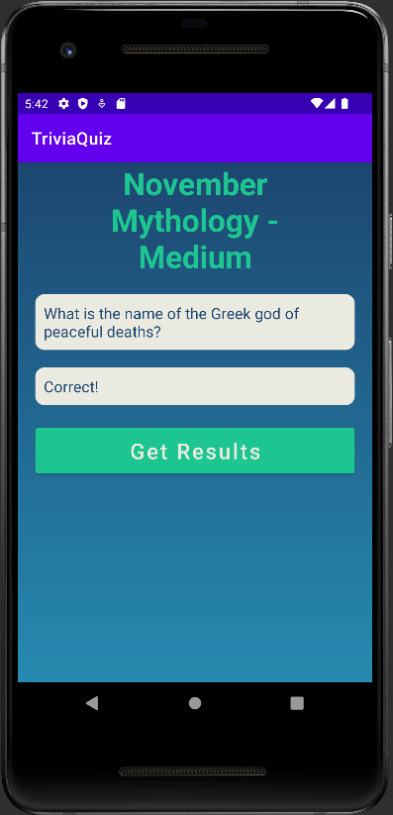

Figure : Final Answer Form.

Once the user has answered all ten questions of the quiz, the results form is displayed with the number of questions the user answered correctly (see figure 18). When the user clicks on the *Return To Main Menu* button, the user is then returned to either the Administration Menu, or the Player Menu, depending on the user.

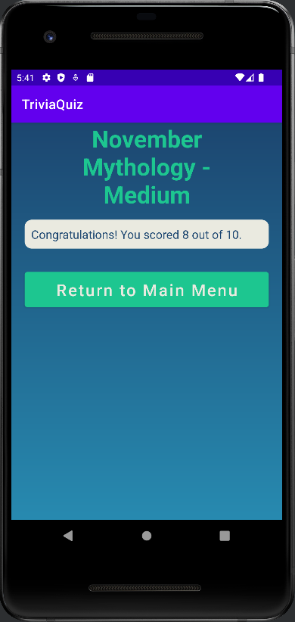

Figure : Quiz Result Form.

## 6.4 Upcoming Quizzes

When the Player clicks on the *Upcoming* button, they are taken to the list of quizzes yet to start (see figure 19). Each listing contains the quiz summary: its name, start date, end date, category and difficulty.

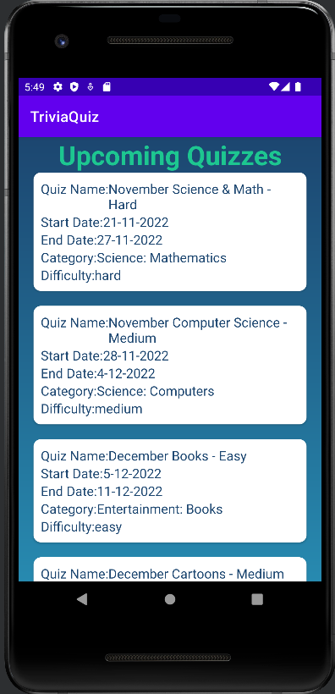

Figure : Upcoming Quizzes.

## 6.5 Past Quizzes

When the Player clicks on the *Past* button, they are taken to the list of past quizzes (see figure 20). Each listing contains the quiz summary: its name, start date, end date, category and difficulty. If the Player has taken the quiz, their score is displayed at the end of the quiz summary.

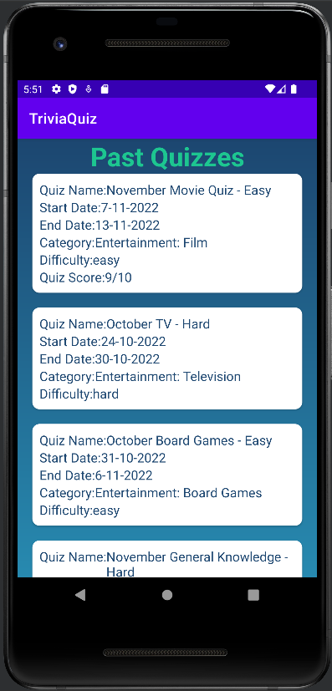

Figure : Past Quizzes.

## 6.6 Participated Quizzes

When the Player clicks on the *Participated* button, they are taken to the list of quizzes they have previously undertaken (see figure 21). Each listing contains the quiz summary: its name, start date, end date, category, difficulty, and the score they achieved.

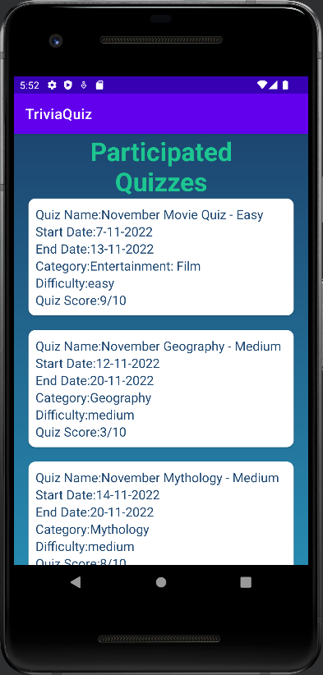

Figure : Participated Quizzes.

## 6.7 Logout

If the Player wants to logout of the application, they can click on the *Logout* button on the Player Menu (see figure 13). They will be returned to the Login form.